H.T No
Regulations:
A15


Sreenidhi Institute of Science and Technology
(An Autonomous Institution)
Code No: 5A510 Date: 01-June-2019 (AN)

B.Tech III-Year I-Semester External Examination, May/June-2019 (Supplementary)
POWER SYSTEMS-II (EEE)

Time: 3 Hours Max.Marks:75

Note: a) No additional answer sheets will be provided.
b) All sub-parts of a question must be answered at one place only, otherwise it will not be valued.
c) Missing data can be assumed suitably.

Part - A Max.Marks:25

Answer all QUESTIONS.

1. | What are the causes of low power factor in power system? | [3M]
2. | Define load duration curve and demand factor. | [3M]
3. | What are the advantages of Gas insulated substation? | [3M]
4. | Define the short circuit capacity of a bus. | [3M]
5. | Define positive, negative and zero sequence components. | [3M]
6. | Classify different DC distribution systems are classified. | [2M]
7. | Define Flat Rate Tariff. | [2M]
8. | What is meant by neutral grounding? | [2M]
9. | Classify different types of faults. | [2M]
10. | What are the advantages of sectionalized bus bar? | [2M]
Part – B Max.Marks:50
ANSWER ANY FIVE QUESTIONS. EACH QUESTION CARRIES 10 MARKS.

11. | a) | Explain the necessity of power factor improvement. | [5M]
 | b) | Explain briefly about the tap changing transformers. | [5M]
12. | a) | A factory has a maximum load of 400kW at 0.8p.f and annual consumption of 4x10⁶ units . The tariff is Rs. 400 per kVA of maximum demand plus 30 paisa per unit. Find out the average price per unit. | [5M]
 | b) | What are the desirable characteristics of a tariff method? | [5M]
13. | a) | Classify different substations and Explain. | [5M]
 | b) | Explain Main and Transfer bus system with a neat diagram. | [5M]
14. | a) | Explain the importance of Per Unit System. | [5M]
 | b) | A generator rated at 40MVA, 11kV has a reactance of 20%. Calculate its per unit reactance for the base of 50MVA, 10kV? | [5M]
15. | a) | Derive the expressions for voltages and current for a Single Line-to-Ground fault on a power system. | [5M]
 | b) | Draw the positive, negative and zero sequence network of all power system components. | [5M]
16. | a) | Discuss the design features of Distribution Systems. | [5M]
 | b) | Distinguish between AC and DC Distribution systems. | [5M]
17. | a) | Explain with neat sketch operation of Booster Transformer. | [3M]
 | b) | What is meant by tariff? Explain about two and three-part tariff. | [4M]
 | c) | Discuss in detail about arcing grounding. | [3M]
18. |  | A 300MVA, 20kV, 3-phase generator has a sub-transient reactance of 15%. The generator supplies two synchronous motors through a 100km transmission line having transformers at both ends as shown below figure.  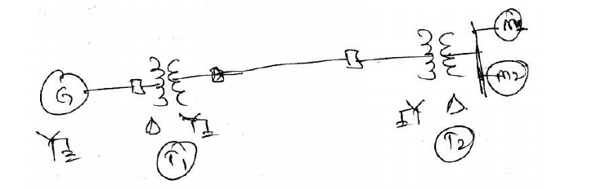  In this T₁ is a 3-phase transformer with 350MVA, 20/230 kV, 10% reactance and T₂ is made of 3 single phase transformers of rating 100MVA 127/13.2 kV, 10% reactance.  Series reactance of transmission lines line L₁ is 0.55 ohm/km, line L₂ is 0.44 ohm/km.  Motors: M₁: 200 MVA, 13.2 kV, X=20%, M₂: 120 MVA, 13.2 kV, X=20%.
 | a) | Draw the reactance diagram with all the reactance’s marked in p.u. Select the generator rating as base values. | [4M]
 | b) | What are the symmetrical components of 3-phase system? | [3M]
 | c) | Compare underground cable and overhead line distribution system? | [3M]

-- 00 -- 00 –

